**SQL Server Test**

1. Get First_Name from employee table using alias name “Employee Name”.

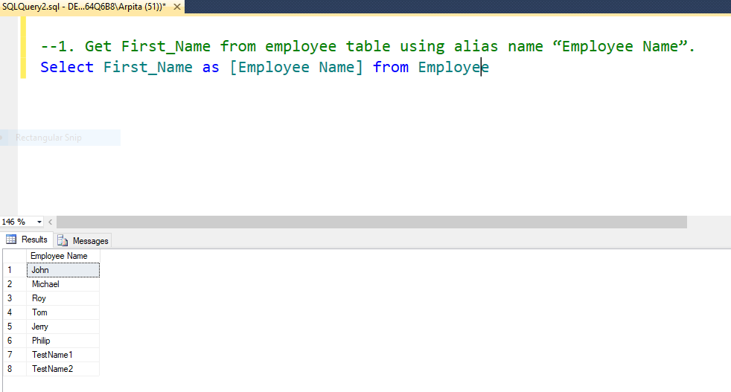

2. Get position of 'o' in name 'John' from employee table .

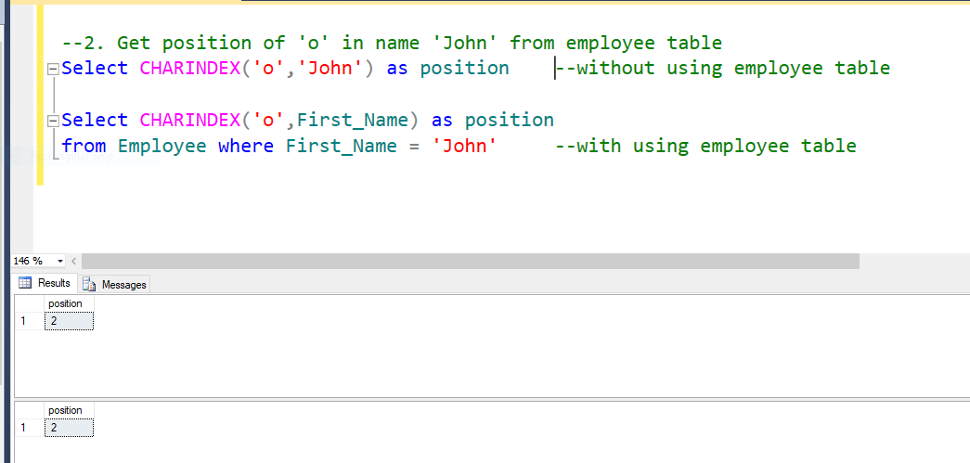

3. Get FIRST_NAME ,Joining year,Joining Month and Joining Date from employee table.

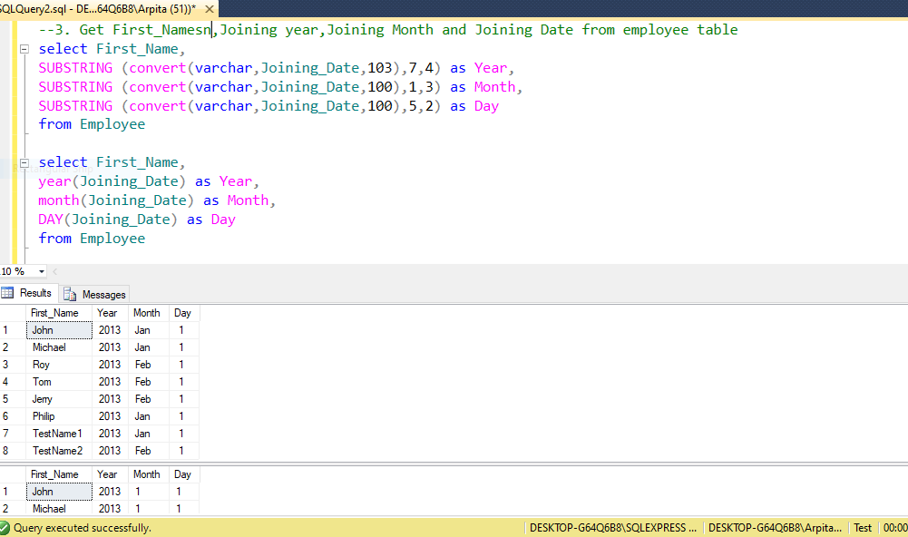

1. Get all employee details from the employee table order by First_Name Ascending and Salary descending.

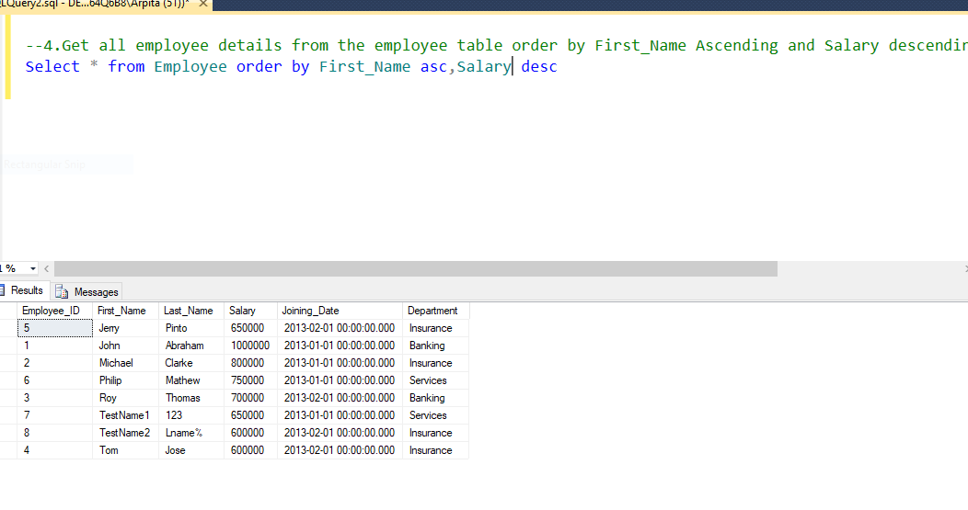

1. Get employee details from employee table whose employee name are not “John” and “Roy”.

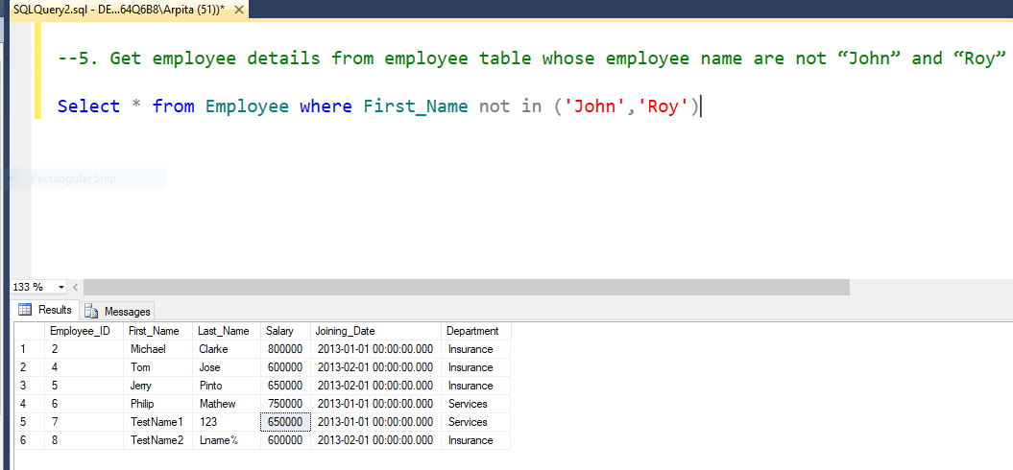

6. Get employee details from employee table whose first name ends with 'n'.

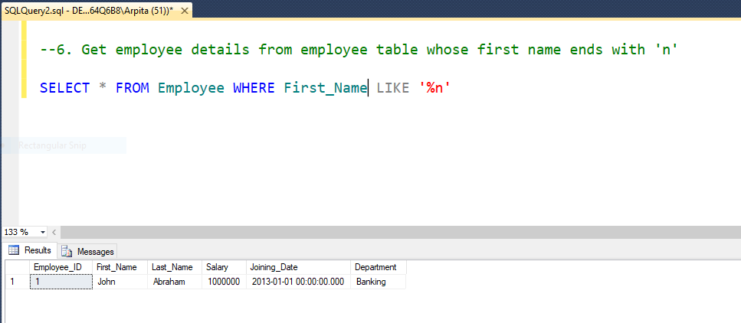

7. Get employee details from employee table whose first name ends with 'n' and name contains 4 letters.

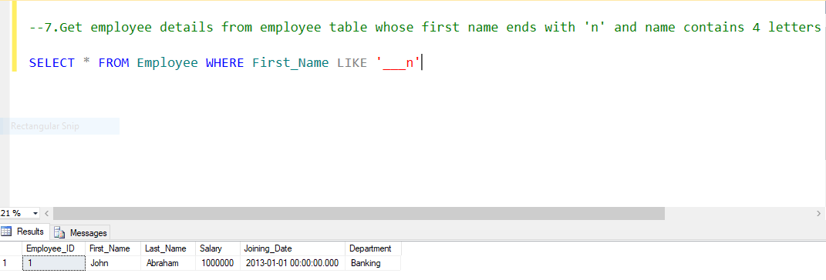

1. Get employee details from employee table whose Salary less than 800000.

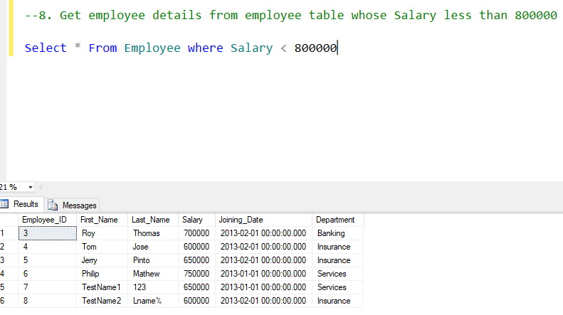

9. Get employee details from employee table who joined before January 1st 2013

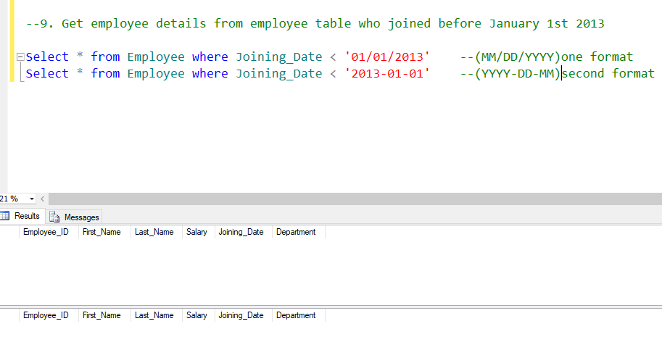

10. Get difference between JOINING_DATE and INCENTIVE_DATE from employee and incentives table

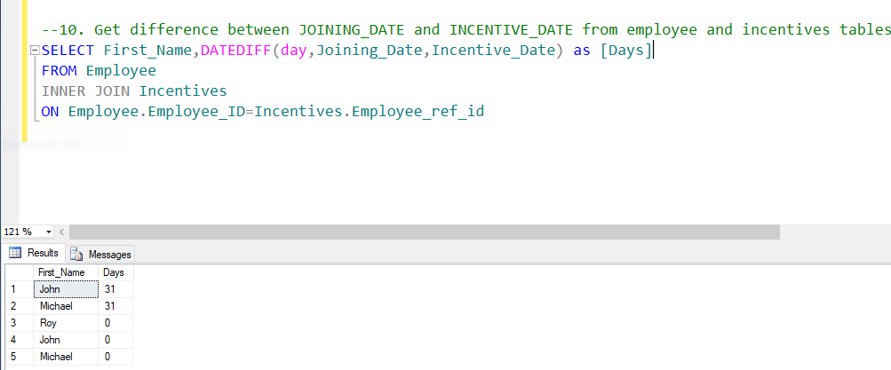

11. Print database date.

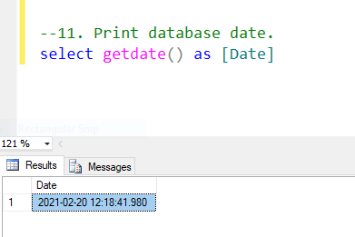

12. Get department,total salary with respect to a department from employee table.

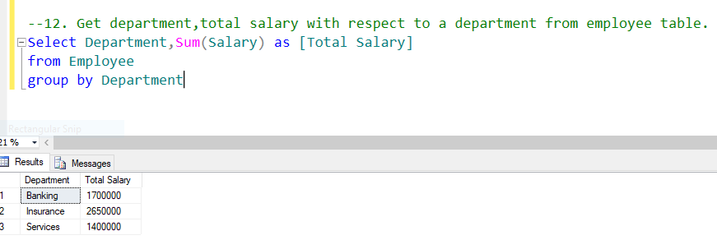

13. Get department,no of employees in a department,total salary with respect to a department from employee table order by total salary descending.

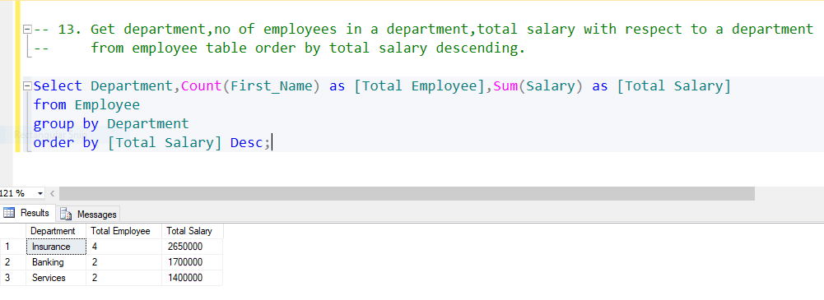

14. Select no of employees joined with respect to year and month from employee table.

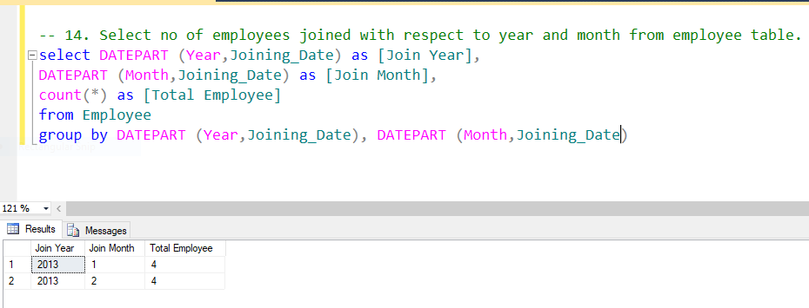

15. Update incentive table with employee's Incentive_amount as '12000' where employee name is 'John'.

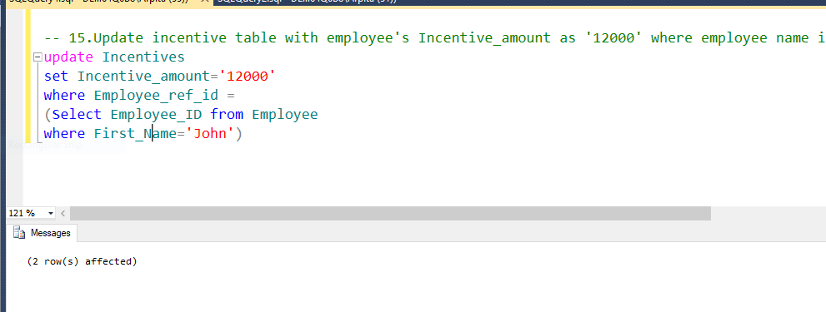

(1)

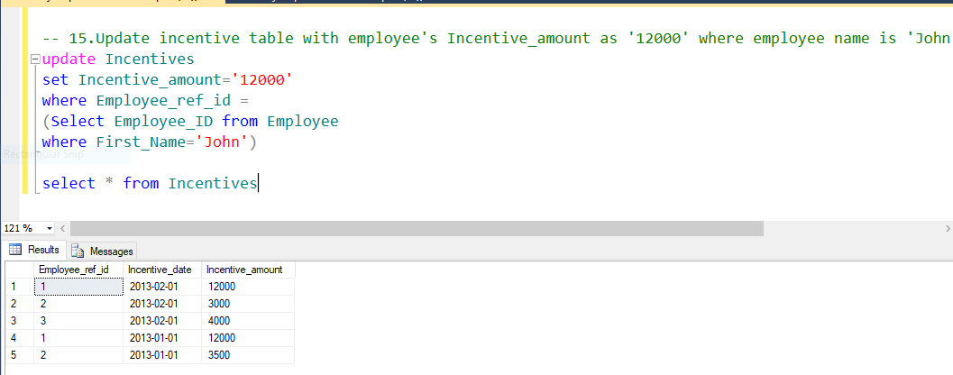

(2)

16. Select TOP 2 salary from employee table.

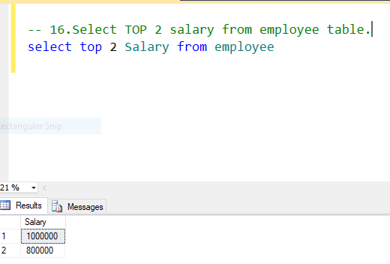

1. Select 2nd Highest salary from employee table.

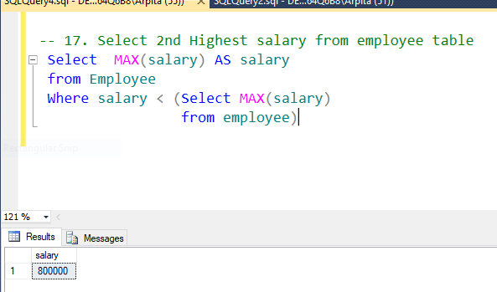

18. Write. What is the difference between UNION and UNION ALL ?

* UNION and UNION ALL both are used to combine the results of two similar queries.
* The only difference between these two is : UNION will eliminate duplicate records in the result set while UNION ALL will include all duplicate rows too.

UNION: only keeps unique records

UNION ALL: keeps all records, including duplicates

* UNION or UNION ALL have the same basic requirements of the data being combined:

1)There must be the same number of columns retrieved in each SELECT statement to be combined.

2)The columns retrieved must be in the same order in each SELECT statement.

3)The columns retrieved must be of similar data types.

* For example, if FIRST_NAME is DOUBLE and LAST_NAME is STRING above query wont work.Since the data type of both the columns are VARCHAR, union is made possible.

19. Write a syntax for CREATE Employee Table.

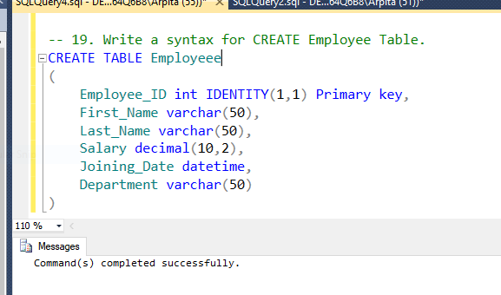

20. Write a syntax for truncate all data from Employee Table.

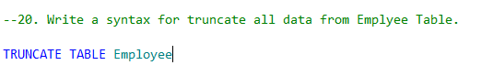

21. Write a syntax for CREATE Procedure to display the Employee details by passing the “Employee Id” in the procedure.

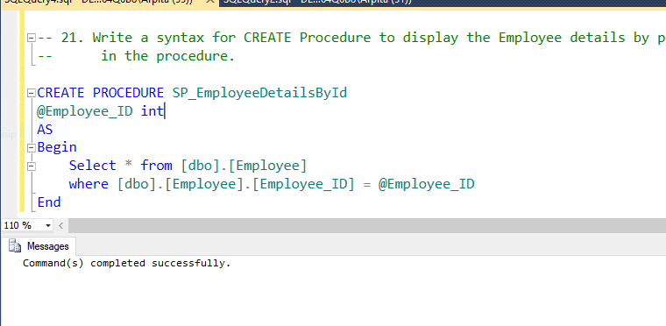

(1)

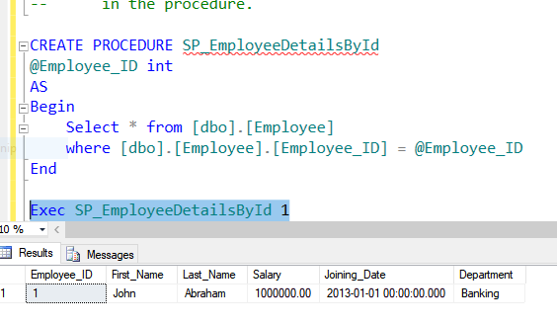

(2)

22. Write a syntax for CREATE SQL function, which accept three number as argument and return the highest number.

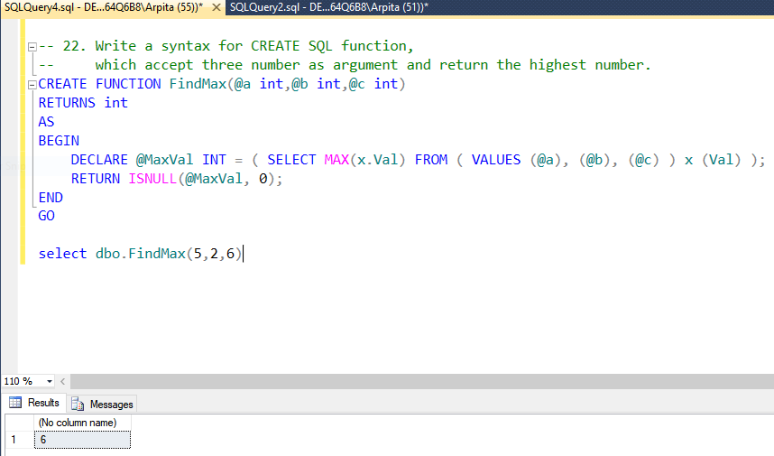

23.Write a syntax for Update the Employee's salary whose department is“Insurance”.

Syntax:

Update Employee

Set Salary=<new Salary>

Where Department = ‘Insurance’

24.State the difference between varchar and nvarchar.

* About the Varchar:

1. It is a variable that has a length data type.
2. It is use to store non-Unicode characters.
3. It Occupy 1 byte(8-bit representation) of space for each character.

Example:DECLARE @name VARCHAR(20)

* About the NVARCHAR data:

1) It is a variable that has length data type.

2) It is use to store Unicode characters.

3) It Occupy 2 bytes(16-bit representation) of space for each character.

Example::DECLARE @name NVARCHAR(20)

1. Write a query that insert the data into Employee table, data as mentioned. {First name : 'Critiano' , Last name : 'Ronaldo' , Salary : '30000' , Joining Date : '01-FEB-13 12.00.00 AM' , Department : 'Banking' }

